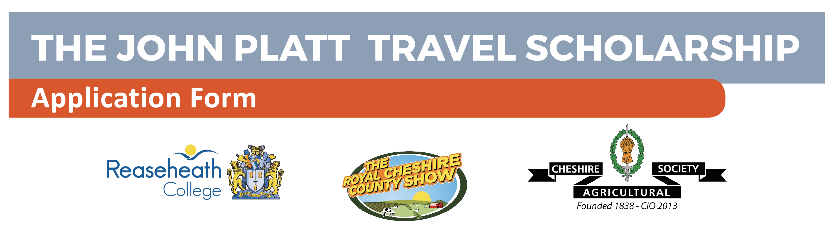

Please complete the form by typing in the information required and submit by any of the following methods:-

A hard copy posted to The Vice Principal, Reaseheath College, Nantwich, Cheshire, CW5 6DF; forwarded as an email attachment to cara.manfredi@reaseheath.ac.uk;
The closing date for applications is 30th April 2020.

Surname
First Name
Title (e.g., Mr/Mrs/Ms/Miss/Other)
Date of Birth
Home Address

How long have you resided at this address?
Home Telephone Number
Home email Address
Present Employer
Work Address

Nature of Business

Work Telephone Number
Brief description of present occupation

Please indicate which project category you are interested in. It is admissible to tick more than one box:

- New technology

- New or alternative farming methods

- Diversification

- Utilisation or sustainability of Natural resources

- Improved profitability within Cheshire agriculture

1. Description of the project: in not more than 100 words
2. Timing: proposed itinerary, duration of tour etc.
3. Has application been made to any other body for funds for this investigation and, if so, with what result?
5. Details of financial support required, including mode and cost of travel, and any other relevant factors:

PLEASE NOTE – References

If you are in employment, you will be required to submit two references with your application. One should be from your current employer on headed notepaper; the other should be a character reference from someone in a professional capacity who has known you for more than two years. If you reside in Cheshire and are engaged in full-time study, you will be required to provide a reference from your tutor as well as a character reference as stated above.

