## Maintain Animal Health and Welfare

**Normal Signs of Health**

By the end of the session you will be able to:

* Give the normal body temperatures of the dog, cat, ,rabbit, g.pig and hamster
* Give the normal heart rates of the dog, cat, rabbit, g.pig and hamster
* Give the normal respiratory rates of the dog, cat ,rabbit, g.pig and hamster
* State how they communicate
* Know their feeding patterns

We can not truly understand what abnormal health is until we understand what normal health is.

You are now going to research in your specialised groups a particular animal’s normal health.



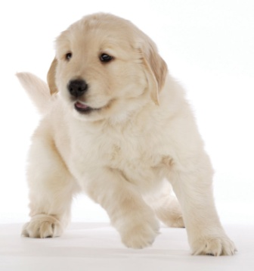**Dog**

**You need to find out about the normal behaviour patterns in the following areas:-**

What is their normal temperature range?........................................................................

What is their normal respiration rate?.............................................................................

What is their normal heart rate?........................................................................................

Sleeping patterns – are they nocturnal/ diurnal?

........................................................................................................................................................................................................................................................................................................................................ Movement- how do these animals move? I.e. run, hop, jump, climb

.......................................................................................................................................................................................................................................................................................................................................

Communicating. How do they communicate with each other?

............................................................................................................................................................................................................................................................................................................................................................................................................................................................................................................

Explain their Feeding patterns – e.g carnivores/predator, scavenger, eat constantly throughout the day?........................................................................................................................................................................................................................................................................................................................................................................................................................................................................................................................................................................................................................................................................

What does their normal faeces look like? Draw a diagram if possible

..............................................................................................................................................................................................................................................................................................................

ADDITIONAL INFORMATION

............................................................................................................................................................................................................................................................................................................

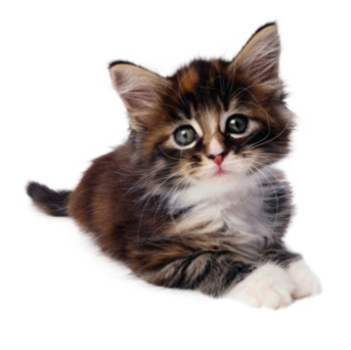**Cat**

**You need to find out about the normal behaviour patterns in the following areas:-**

What is their normal temperature range?........................................................................

What is their normal respiration rate?.............................................................................

What is their normal heart rate?........................................................................................

Sleeping patterns – are they nocturnal/ diurnal?

........................................................................................................................................................................................................................................................................................................................................ Movement- how do these animals move? I.e. run, hop, jump, climb

.......................................................................................................................................................................................................................................................................................................................................

Communicating. How do they communicate with each other?

............................................................................................................................................................................................................................................................................................................................................................................................................................................................................................................

Explain their Feeding patterns – e.g. carnivores/predator, scavenger, eat constantly throughout the day?........................................................................................................................................................................................................................................................................................................................................................................................................................................................................................................................................................................................................................................................................

What does their normal faeces look like? Draw a diagram if possible

..............................................................................................................................................................................................................................................................................................................

ADDITIONAL INFORMATION

............................................................................................................................................................................................................................................................................................................

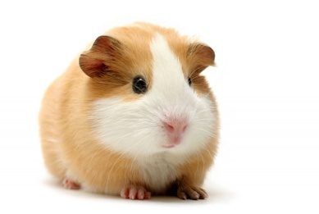**Guinea Pig**

**You need to find out about the normal behaviour patterns in the following areas:-**

What is their normal temperature range?........................................................................

What is their normal respiration rate?.............................................................................

What is their normal heart rate?........................................................................................

Sleeping patterns – are they nocturnal/ diurnal?

........................................................................................................................................................................................................................................................................................................................................ Movement- how do these animals move? I.e. run, hop, jump, climb

.......................................................................................................................................................................................................................................................................................................................................

Communicating. How do they communicate with each other?

............................................................................................................................................................................................................................................................................................................................................................................................................................................................................................................

Explain their Feeding patterns – e.g. carnivores/predator, scavenger, eat constantly throughout the day?........................................................................................................................................................................................................................................................................................................................................................................................................................................................................................................................................................................................................................................................................

What does their normal faeces look like? Draw a diagram if possible

..............................................................................................................................................................................................................................................................................................................

ADDITIONAL INFORMATION

.............................................................................................................................................................................................................................................................................................................

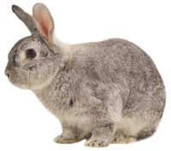**Rabbit**

**You need to find out about the normal behaviour patterns in the following areas:-**

What is their normal temperature range?........................................................................

What is their normal respiration rate?.............................................................................

What is their normal heart rate?........................................................................................

Sleeping patterns – are they nocturnal/ diurnal/crepuscular?

........................................................................................................................................................................................................................................................................................................................................ Movement- how do these animals move? I.e. run, hop, jump, climb

.......................................................................................................................................................................................................................................................................................................................................

Communicating. How do they communicate with each other?

............................................................................................................................................................................................................................................................................................................................................................................................................................................................................................................

Explain their Feeding patterns – e.g. carnivores/predator, scavenger, eat constantly throughout the day?........................................................................................................................................................................................................................................................................................................................................................................................................................................................................................................................................................................................................................................................................What does their normal faeces look like? Draw a diagram if possible

..............................................................................................................................................................................................................................................................................................................

ADDITIONAL INFORMATION

............................................................................................................................................................................................................................................................................................................

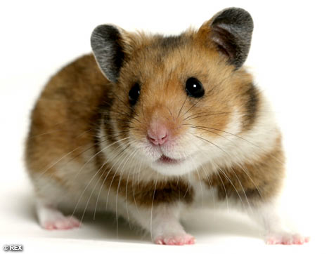**Hamster**

**You need to find out about the normal behaviour patterns in the following areas:-**

What is their normal temperature range?........................................................................

What is their normal respiration rate?.............................................................................

What is their normal heart rate?........................................................................................

Sleeping patterns – are they nocturnal/ diurnal?

........................................................................................................................................................................................................................................................................................................................................ Movement- how do these animals move? I.e. run, hop, jump, climb

.......................................................................................................................................................................................................................................................................................................................................

Communicating. How do they communicate with each other?

............................................................................................................................................................................................................................................................................................................................................................................................................................................................................................................

Explain their Feeding patterns – e.g. carnivores/predator, scavenger, eat constantly throughout the day?........................................................................................................................................................................................................................................................................................................................................................................................................................................................................................................................................................................................................................................................................

What does their normal faeces look like? Draw a diagram if possible

..............................................................................................................................................................................................................................................................................................................

ADDITIONAL INFORMATION

.............................................................................................................................................................................................................................................................................................................