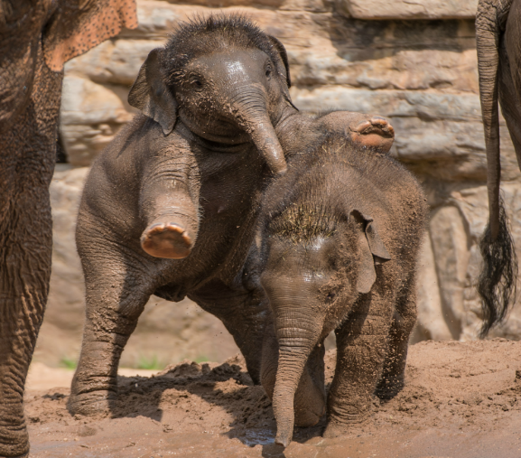
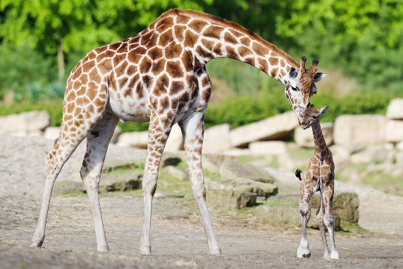
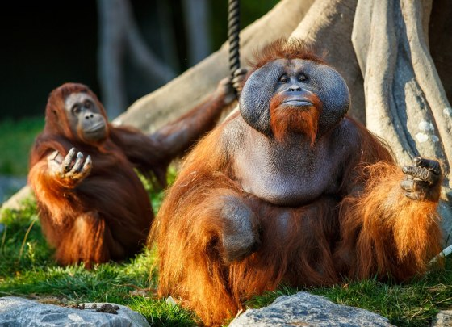
Zoo to you … task.
Collecting data from the comfort of your own home.
You will need to scan the QR Code to take you to the Wakelet, to select a live feed of an animal across the world.
Also, available on teams.
https://wakelet.com/wake/187dfb1d-9fb8-40d9-8de2-115c4f18971f

Ensure you select one of the active animals.

If the animal is not visible, please select another.
We do not want out of sight data.

SCAN QR CODE

What is an ethogram?
Sun-Bathing
- A list of all the animal behaviour patterns an animal has in its repertoire (body position, movements) observed by an observer.
Examples:
Walking: One foot in front of the other in a forward motion, at a slow pace.
Eating: Using hand to move food item towards its mouth, then opening and closing its jaws.

You will need to create an ethogram of ten (10) behaviours for the chosen animal. Conduct some research on your animal.

____________________________________________________________________________________________________________________________________________________________________________________________________________________________________________________________________________________________________________________________________________________________________________________________________________________________________________________________________________________________________________________________________________________________________________________________________________________________________________________________________________________________________________________________________________________________________________________________________________________________________________________________________________________________
Behaviour | Definition

Instantaneous Sampling
- Instantaneous sampling is when you record the behaviour at set time intervals, for example, every minute.
You need to utilise this method to conduct observations of your chosen animal, observing the ten behaviours.
Findings:
____________________________________________________________________________________________________________________________________________________________________________________________________________________________________________________________________________________________________________________________________________________________________________________________________________________________________________________________________________________________________________________________________________________________________________________________________________________________________________________________________________________________________________________________________________________________________________________________________________________________________________________________________________________________________________________________________________________________________________________________________________________________________________________________________________________________________________________________________________________________________________________________________________________________________________________________________________________________________________________________
Observe again.
Conclusion:
Did you notice any differences?
What effect do you believe lockdown is having on the animals?
Any suggestions concerning behaviour?
In your research did you find anything wild behaviour based.
Did you see any abnormal behaviours?
________________________________________________________________________________________________________________________________________________________________________________________________________________________________________________________________________________________________________________________________________________________________________________________________________________________________________________________________________________________________________________________________________________________________________________________________________________________________________________________________________________________________________________________________________________________________________________________________________________________________________________________________________________________________________________________________________________________________________________________________________________________________________________________________________________________________

