Level 3 Ecology Predator & Prey Research Task

Research Predators and Prey and complete the examples 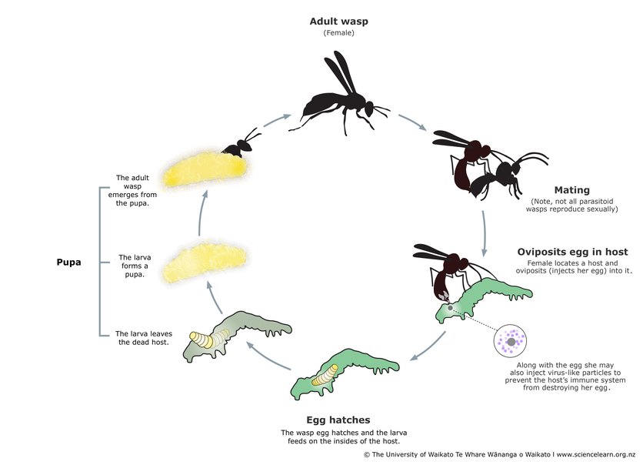

Predator Tactics Examples

1. Cryptic Colouration _____________________________________________________­­­­­­­__________________________________________________________________________________________________________________________________________________
2. Deception (mimicking/ luring prey) ___________________________________________

__________________________________________________________________________________________________________________________________________________

1. Chemical poisons/Chemicals may be injected or sprayed__________________________

__________________________________________________________________________________________________________________________________________________

1. Forming Groups __________________________________________________________

__________________________________________________________________________________________________________________________________________________

**Ambush**

**Lying in wait for p­rey to come along.**

**Examples _____________________________________________________________________________________________**

**­­­­­­­Success Rate - Low**

**Energy expenditure: low cost**

**Stalking**

**Deliberate form of hunting with a quick attack.**

**Examples _____________________________________________________________________________________________**

**Searching: can be a long time, high energy cost**

**Actual pursuit: a short time, low energy cost (compare with time searching)**

**Pursuit**

**Pursuit hunting is typically seen in animals that know the location of their prey**

**Examples _______________________________________________________________________________________**

**Search time is minimal. Low energy expenditure.**

**Pursuit time is great. High energy expenditure**

**Prey Defences**

|  |  |
| --- | --- |
| **Chemical defence** | **Cryptic colouration** |
| **Warning coloration** | **Batesian mimicry** |