How is doing Maths at Reaseheath different to school?
You will study one of the following:
- GCSE (all students with a grade 3 must follow this route)
- Functional Skills Maths at Entry level, Level 1 or Level 2.

The lessons are broken into 6 chunks: Routine, Recall, Revise, Repeat, Ready and Reflect.
Routine activities to ensure you practise, practise, practise.
Recall – activities to help you remember key facts
Revise – the topic of the lesson that is reviewed
Repeat – questions to repeat the key topic
Ready – are you ready to answer exam questions on the topic?
Reflect – How have you done?

Some Examples…
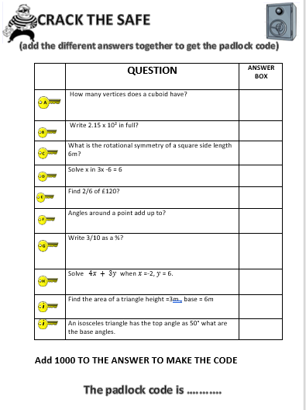
Routine activities like - Crack the safe
We use activities like this at the beginning of the lesson. This is a ROUTINE, which allows the learner to practise key skills.
The fun bit…
The answers to each question add up to a 4-digit number which is the code to a padlock. Get the right code and open the safe to win the sweets or chocolate.

Weekly ‘Strive for 5’ quizzes!
Students complete a set of 30 questions each week in a 5 minute period. The idea is for students to answer as many questions correctly as possible. Their scores correspond to a Martial arts belt colour and is tracked each week to show progress!
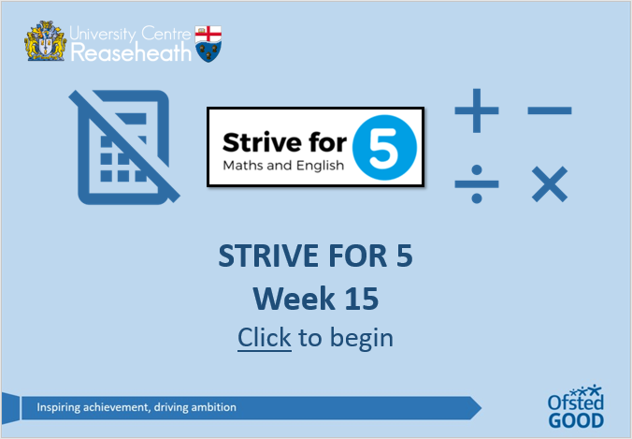

Routine Retriever – a starter activity that covers a range of questions/topics covered in previous lessons, for example, our Fold & Solve – students fold the Hints section and only use it when they need support!
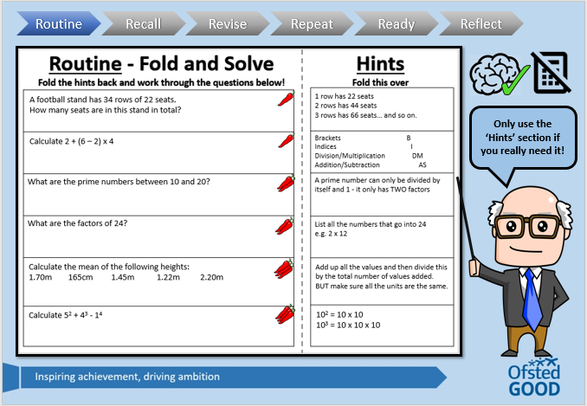

RECALL – Recall key facts with fun games like Bingo or Catchphrase.
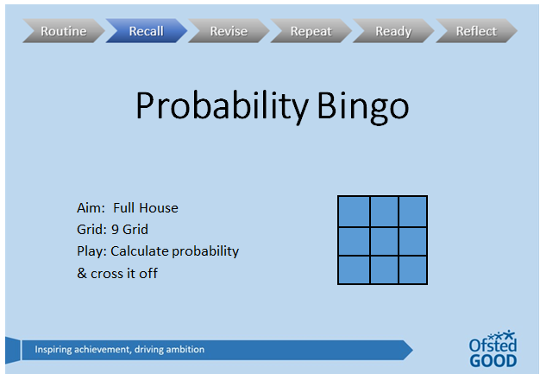
We use activities such as BINGO and catchphrase as fun and engaging ways, to help students to recall key facts and to practise key skills. –
Full house wins a prize!

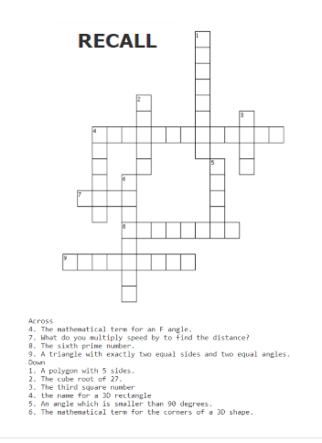
Crosswords – to learn key terminology used in exams

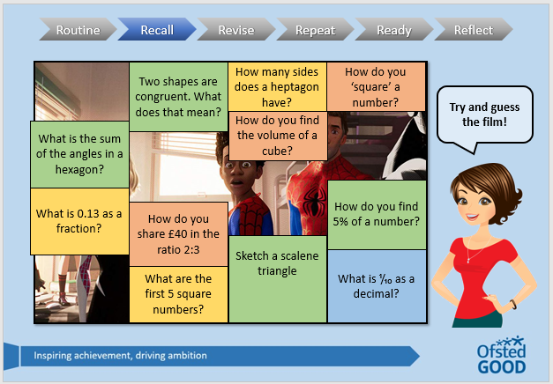

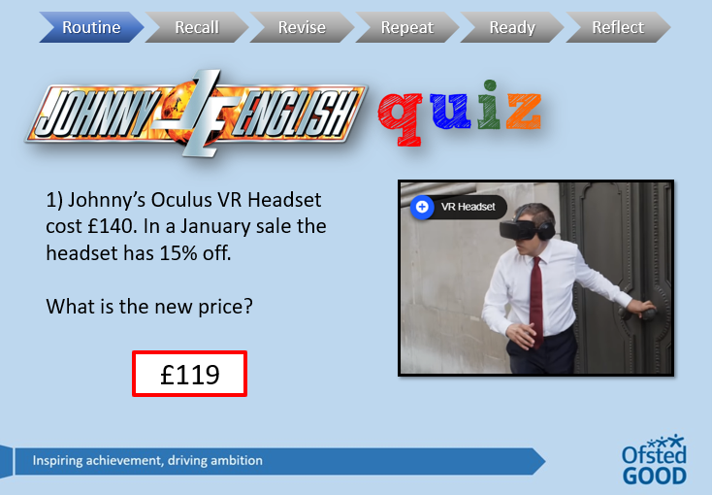
H5P
Maths embedded into movie clips.
Engages the students, adds a competitive edge and is entertaining.

Questions are contextualised to the student’s courses, so they are more engaging, interesting to the students because they see how maths relate to their vocation.

Sport
