Before you Begin – You will be asked for the below information during the online process. Please have the information

- Learner Reference number
Your Learner Reference Number will on your Invitation to Enrol Email.
- Photo (Should be 480 height x 640 width pixels maximum, .jpeg or .jpg, head and shoulders only
You can still complete your online enrolment form and send your photograph in later to fephotos@reaseheath.ac.uk
- Statement of Results Certificate (Only applies if you are already in receipt of this e.g 19+ learners)
- Passport Number (required if Student is non-British only)
- GP Details
Accessing your Online Enrolment Form

After receiving your offer of admission to the college, you can expect to receive an email from Reaseheath.ac.uk. This email will contain an invitation for you to complete the online enrolment process.

Welcome to the Reaseheath College Online Enrolment system! We are delighted to provide you with a convenient way to capture essential personal information prior to the commencement of your course.
Personal Enrolment Form Starting Page
On clicking the link to your personal online enrolment form, you will arrive at the below page which will confirm the course title you are enrolling to.
To begin completing your enrolment click on the below link.
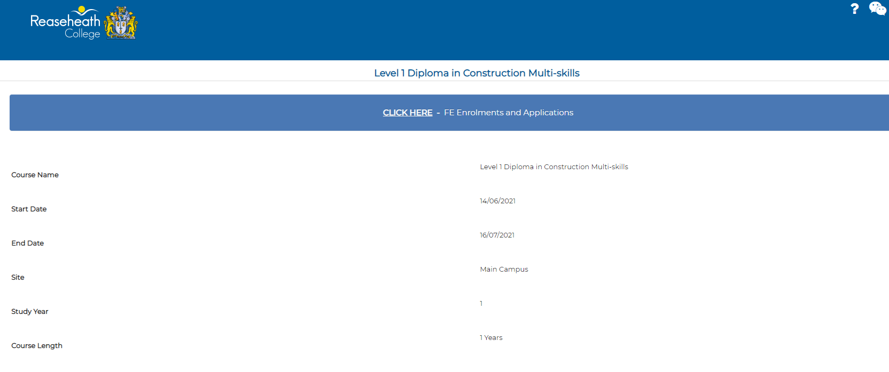

Then click on Enrol for Course
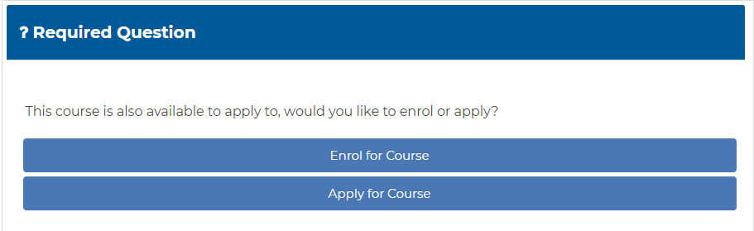
Tips
* Highlights which are required mandatory fields.
Hovering of this symbol will provide additional information to help you complete the form.
Page 1 Your Personal Details
You will be asked to confirm the following:  - Your Learner Reference Number  - Forename  - Surname  - Date of Birth  - Your ‘Known As’ name if this differs from your legal forename.  - House Number  - Post Code | 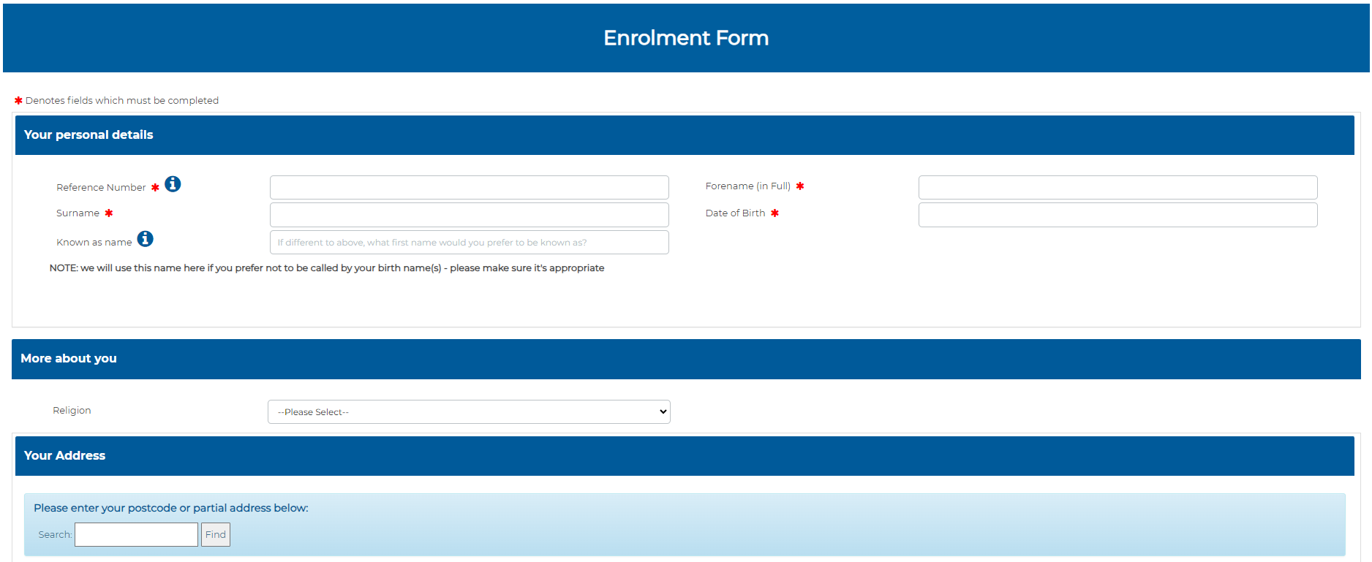

Page 1 Expanded - Your Personal Details - Continued
Page 2 will confirm the remainder of your address.

You will be asked to confirm the following:

- Your Address
- Number of Years at Address (If less than 1 year please put 0).

Click Next

Page 2 Your Personal Details – Continued, Doctors and Medical Information
You will be asked to confirm the following:  - Country of Residence  - Country of Birth  - Ethnicity  - Home Telephone  - Mobile Telephone  - Personal Email Address  - Criminal/Pending Convictions  - Residential Status  e.g lived in UK  - Learning Difficulties or Disabilities.  If selected Yes, you will be asked to confirm the Primary Disability or Difficulty e.g., Dyslexia  You will also be asked to provide your Doctors Information and confirm any Medical Conditions.  Click Next | 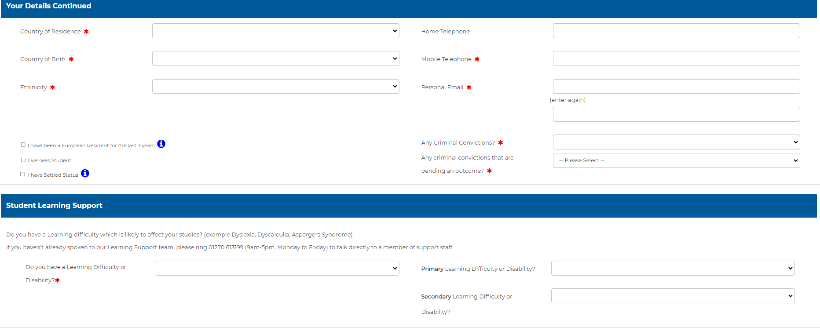  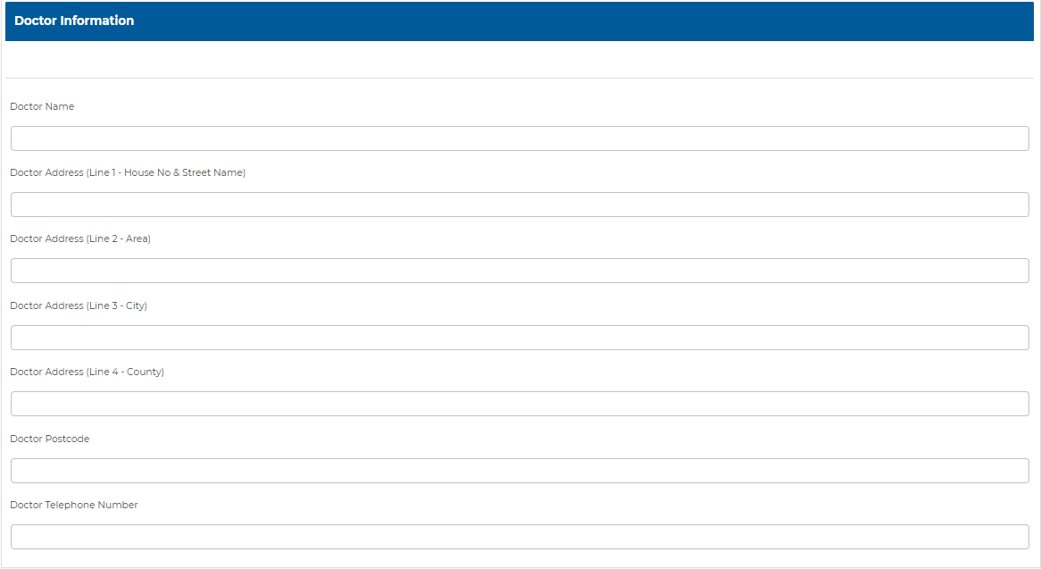  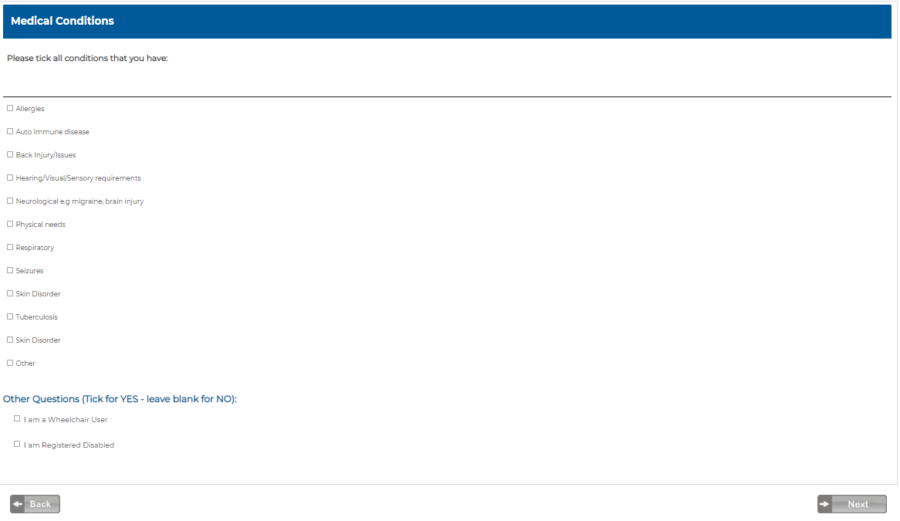

Page 3 Additional Information and Emergency Contacts
You will also be asked to provide at least one emergency contact number.  Click Next | 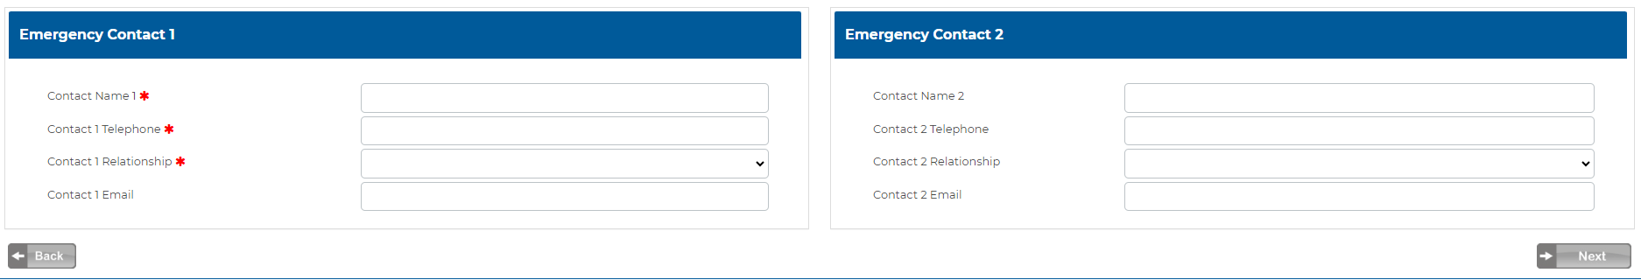

Page 4 Over 19 information, Vehicle Details, Year 11 GCSE Maths & English Grades, Photo Upload
You will be asked to confirm the following:  - Course Payment Information for Over 19’s.  - Employment status for over 19’s.  - Car Details are required for students wishing to park on the College Campus.  - You will also be asked to provide your Year 11 Maths and English Achievements.  - Uploading your GCSE or Results Slips can be done here if you already have them. e.g 19+ learners.  If you have your passport size photo available this can be uploaded on this page.  You can still submit the enrolment form and then send your photograph later to the following email address:  fephotos@reaseheath.ac.uk  Click Next | 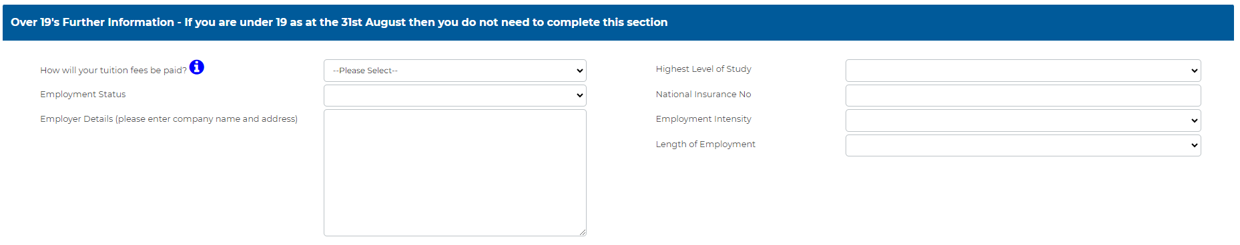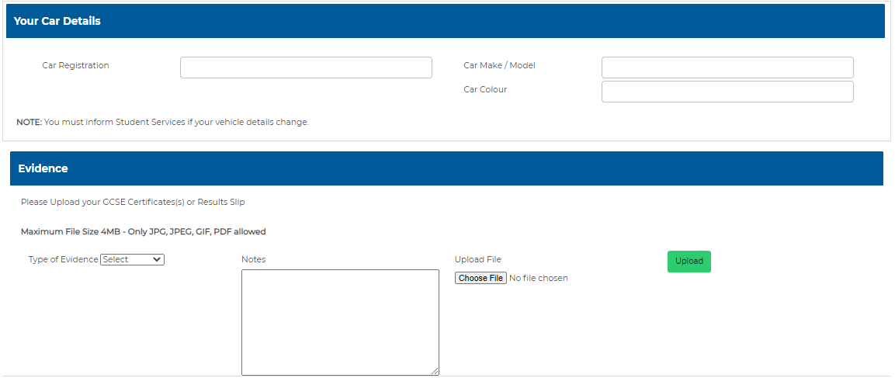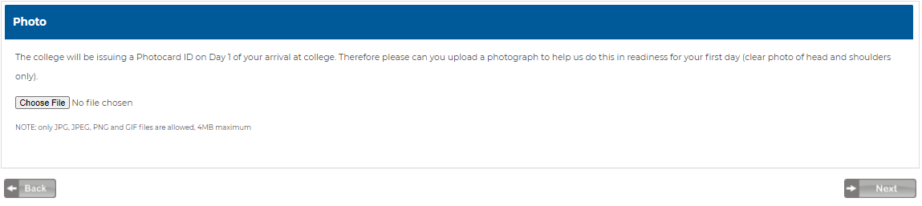

Page 5 Skills Funding Agency Privacy Notice, Contact Preferences and GDPR
You will be asked to confirm the following:  - That you have read and agreed to the ESFA Privacy Notice  Your Contact Preferences in relation to college communication  - Your Contact Preferences in relation to GDPR and the use of your data  Click Next | 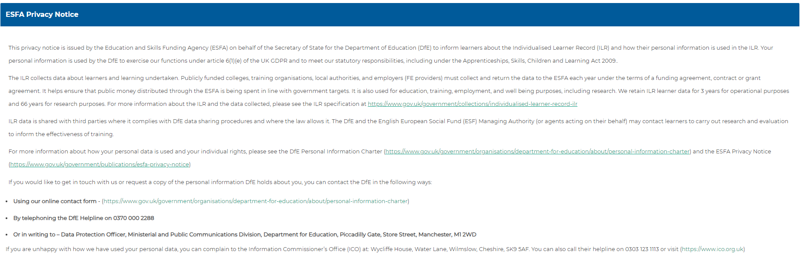  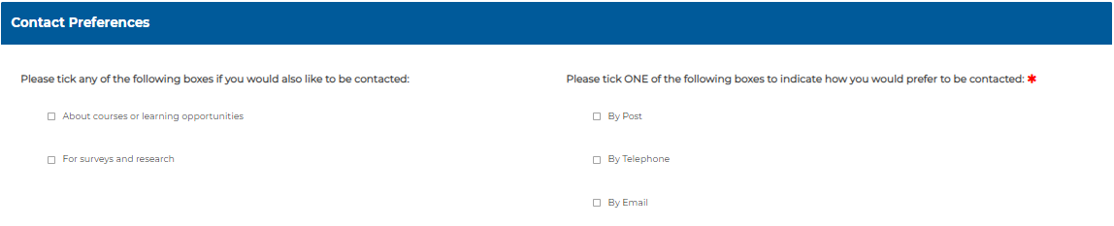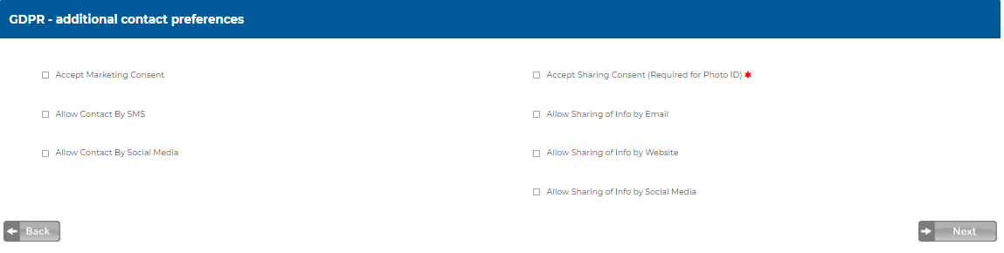

Page 6 Student Declaration
You will be asked to confirm the following:  - That you have read and agreed to the College Student Declaration  Click  Complete Enrolment | 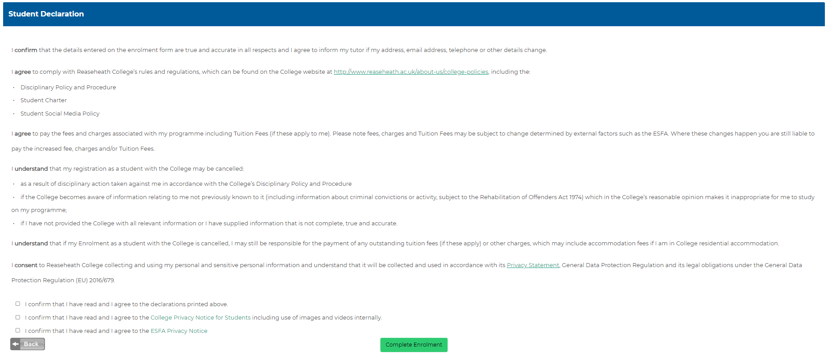
Congratulations you have now completed your Online Enrolment!
Once your enrolment is received, we will promptly process it and send you an acknowledgement email. Within 48 hours of enrolling, you will receive another email which will contain your details on how to activate and access your college account. You will be receiving several pieces of important communication from the college that you need to be aware of, read and electronically sign before you arrive in September so, please remember to regularly check your college email account.
On some occasions the emails from Reaseheath College may arrive in your Junk Email Folder. Please check your junk folder.

