
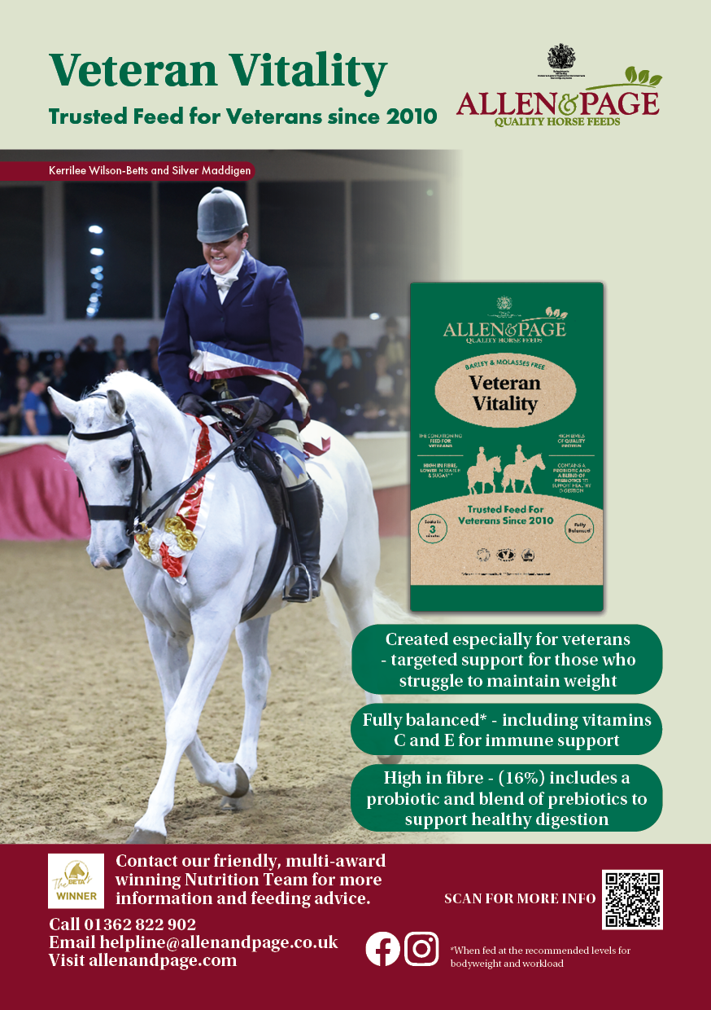
Veteran Horse Society - REGIONAL FINAL 2026.

Second round qualifier for the
Veteran Horse Society Supreme Final

Kindly Sponsored by Allen & Page.

All competitors and grooms must adhere to VHS 2026 Rules in all circumstances. Failure to do so may result in immediate disqualification. Only fully qualified Members holding a current VHS showing card with a valid qualification signature may enter. The card must be carried in the ring and produced on request – no exceptions will be made.

VHS Supreme Final qualification. Competitors placed 1st and 2nd in each class will qualify for the corresponding class at the VHS Supreme Final, to be held at the National Veteran Championships, Arena UK, Lincolnshire. 4th – 6th September. For classes with fewer than 5 entries forward, Supreme Final qualifications will be awarded at the judge’s discretion and are not guaranteed.
If the competitor has already qualified or does not wish to attend, they must refuse the qualification and pass it down the line on the day. Hand your show card to the judge for signing.

VHS M&M Supreme Final qualification. Only given at the judges discretion. The highest placed M&M in each class will qualify for the VHS M&M Supreme Final at the National Veteran Championships. Registered Breeds only may enter. Competitors to have their M&M section signed by the judge during placings.
For further information on qualification or membership please visit the VHS website www.veteran-horse-society.co.uk or telephone the VHS Show Office on 01239 881300 or 07789 514004.

CLASS 1 | DIAMOND VETERAN IN-HAND (25 years and over). Open to horses and ponies of any breed and height. Highest placed registered M&M to qualify forward to the M&M Supreme Final - at the judges discretion.
CLASS 2 | VETERAN IN-HAND (20–24 years). Open to horses and ponies of any breed and height. Highest placed registered M&M to qualify forward to the M&M Supreme Final - at the judges discretion.
CLASS 3 | PRE-VETERAN IN-HAND (15–19 years). Open to horses and ponies of any breed and height. Highest placed registered M&M to qualify forward to the M&M Supreme Final - at the judges discretion.

CLASS 4 | DIAMOND VETERAN RIDDEN (25 years and over). Open to horses and ponies of any breed and height. Highest placed registered M&M to qualify forward to the M&M Supreme Final - at the judges discretion.
CLASS 5 | VETERAN RIDDEN (20–24 years). Open to horses and ponies of any breed and height. Highest placed registered M&M to qualify forward to the M&M Supreme Final - at the judges discretion.
CLASS 6 | PRE-VETERAN RIDDEN (15–19 years). Open to horses and ponies of any breed and height. Highest placed registered M&M to qualify forward to the M&M Supreme Final - at the judges discretion.

